**Assignment 2.2 – Memory Matching Game**

This assignment is about an event programming and JavaFX components.

You will develop the Memory Matching Game in JavaFX. For this example,

there are 8 couples from 16 cards. First the program must let user to watch about 2 or 3 seconds.

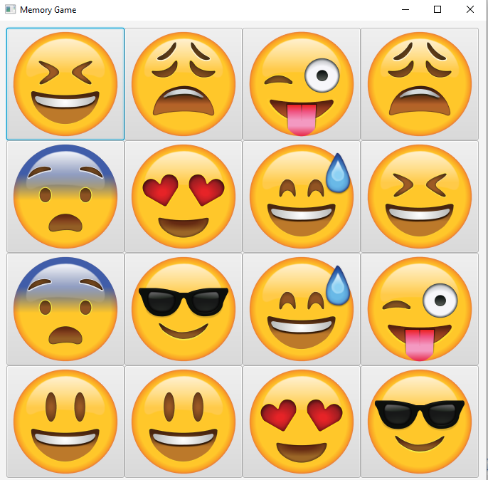

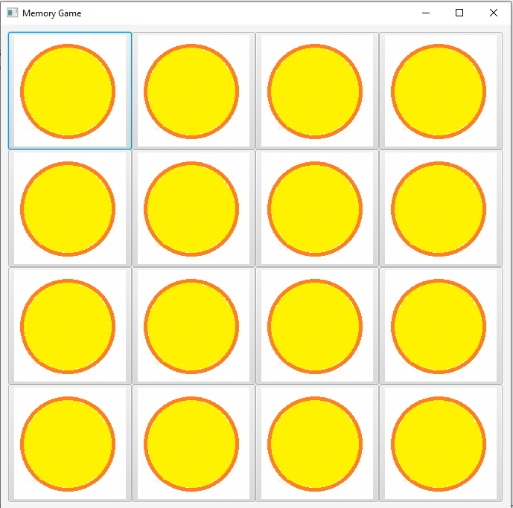And then closing all of cards.

If user select the correct couple, the program must show the corrects and set the buttons as unclicked buttons.

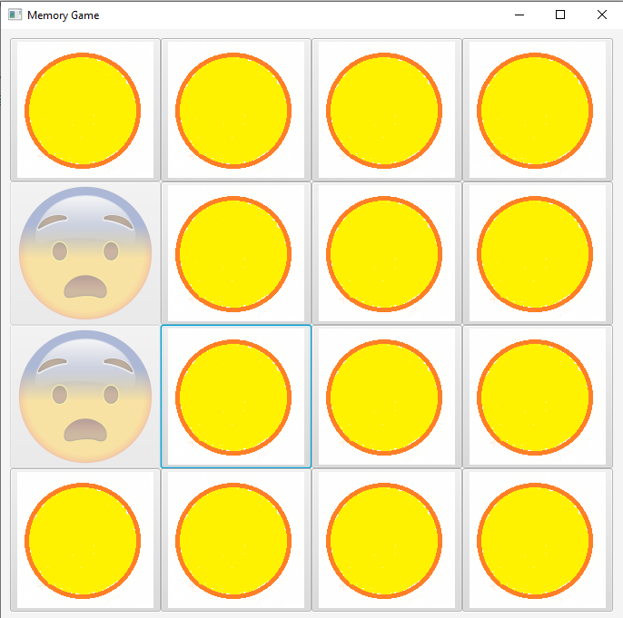

If user selects the incorrect couple, the program must delay 0.5 to 1 second to let the user to watch before turn the incorrect couple back.

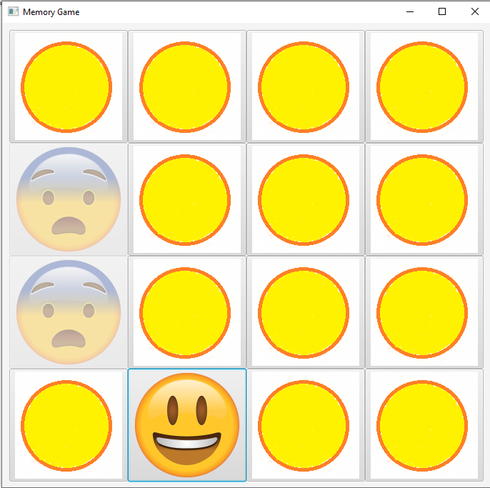

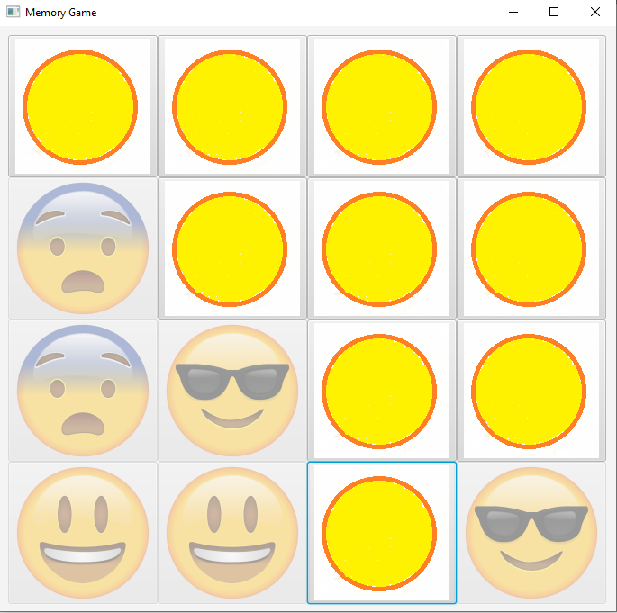

When the game is over, you should show the dialog message using Alert class and let user to choose for continue and exit the program.

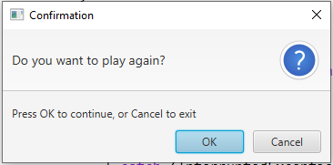

**Submission**

After completing this programming assignment, zip up all the classes and java file. The name of zip file MUST be COP3809_ASSIGNMENT22_SYY_XXXX.zip where YY is 01, 02 or 03 and XXXX is student id.

**Note: You can customize the Pane Layout, decorate the buttons with any images and feel free to prettify the user interface. In this sample, using image sizes 100x100.**